**WERC 2025 Final Technical Report**

**Team Name:** *Renewable Energy Solution for Water & Environmental Restoration*  
**Institution:** New Mexico State University

**Team Members:**

* Naiqui Armendariz (AE/ME)
* Roberto Moreno (ME)
* Sohan Dissanayake (AE/ME)
* TJ Bell (Engineering Physics)
* Wyatt Ziehe (AE/ME)

**Advisor:** Luke Nogales, MET Coordinator, NMSU

**Email Contact:** narmen14@nmsu.edu | Phone: (575) 637-0077

**I. Executive Summary**

Wildfires dramatically degrade soil and water systems, often requiring decades for natural recovery. Our system accelerates the recovery process to 3–5 years using a wind-powered filtration system built from natural materials and monitored in real time via low-cost electronics. The project emphasizes sustainable materials, off-grid operation, and affordability for use in vulnerable communities.

**II. Problem Definition**

Wildfires introduce ash, debris, herbicides, and heavy metals into water and soil systems. Traditional remediation is costly, slow, and requires electricity. Our task was to engineer a low-cost, off-grid system to filter runoff and accelerate soil regeneration while monitoring the effectiveness of the process.

**III. Engineering Requirements & Metrics**

**IV. System Overview**

**A. Water Filtration System**

Filtration occurs in a column using gravity-fed water, driven by a wind-powered pump through layers of:

* Gravel and sand – sediment removal
* Lava rock – mineral filtration
* Coconut activated charcoal – chemical adsorption
* Cotton – fine particle capture

**B. Wind-Powered Delivery**

A vertical-axis wind turbine (~2.3 m tall) powers a Seaflo 42 Series diaphragm pump, which pushes 20L of water in ~6.5 minutes through the filter and soil box.

**C. Monitoring System**

Sensors connected to an ESP8266 microcontroller track:

* Soil moisture and temperature
* pH and conductivity
* Data logged daily and correlated with filter performance.

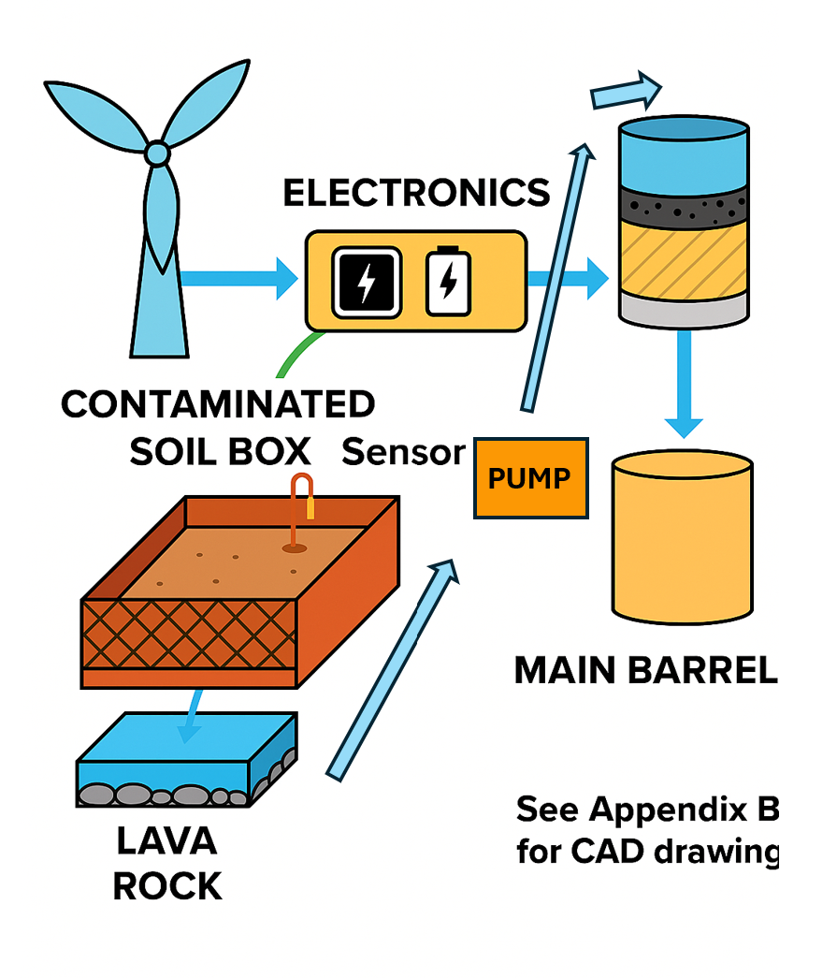

Figure 1  
Flow diagram showing the complete system architecture from wind turbine to water collection, filtration, and sensor data collection. See Appendix B for CAD and additional visuals.

**V. Testing Protocol**

Simulated wildfire contamination was created using:

* Ash-charred soil
* Glyphosate herbicide
* Nitrogen fertilizer
* Garden lime (pH control)

**Procedure:**

* Each day: Add 20L of water → record flow time and volume
* Measure water quality pre- and post-filter
* Track soil moisture and pH daily using sensors
* Visual clarity and physical signs observed

**VI. Results**

**VII. Financial Assessment**

B. Scalability Estimate

* Estimated cost per deployable unit: $4,500–$6,000
* Designed to cover ~1-acre post-fire zone
* Scalable through bulk purchase, grant support, and simplified framing

C. Lifespan of Major Components

VIII. Stakeholder Relevance

**IX. Future Recommendations**

* Replace coconut charcoal with pre-treated carbon to avoid early leach
* Expand data logging and remote access capabilities
* Explore battery integration with charge controller for hybrid use
* Extend soil trials to 4–8 weeks for long-term data

**X. Conclusion**

This project provides a low-cost, sustainable solution for soil and water restoration in wildfire-affected areas. By using wind energy and natural filtration media, we offer a system that is affordable, effective, and replicable in regions most at risk. With continued testing and scaling, this design could become part of national post-fire recovery efforts.

**Appendix A – Financials**

**Appendix B – Technical Drawings & CAD Models**

**Appendix C – Testing Data & Logs**

**Table 2** Water quality results across six sample tests before and after filtration through the renewable remediation system. Parameters measured include turbidity (NTU), pH, and electrical conductivity (μS or mS), as well as qualitative observations using heavy metal test strips. Samples 4 and 5 include a second filtration cycle for comparative analysis.

**Table 3 Flow Rate Calculation Summary for Five Trials**  
Each trial involved collecting 20 liters of water over 6.54 minutes. The average flow rate was consistently measured at 3.06 L/min across all trials. These values indicate the system’s reliability and steady performance during multiple filtration cycles.

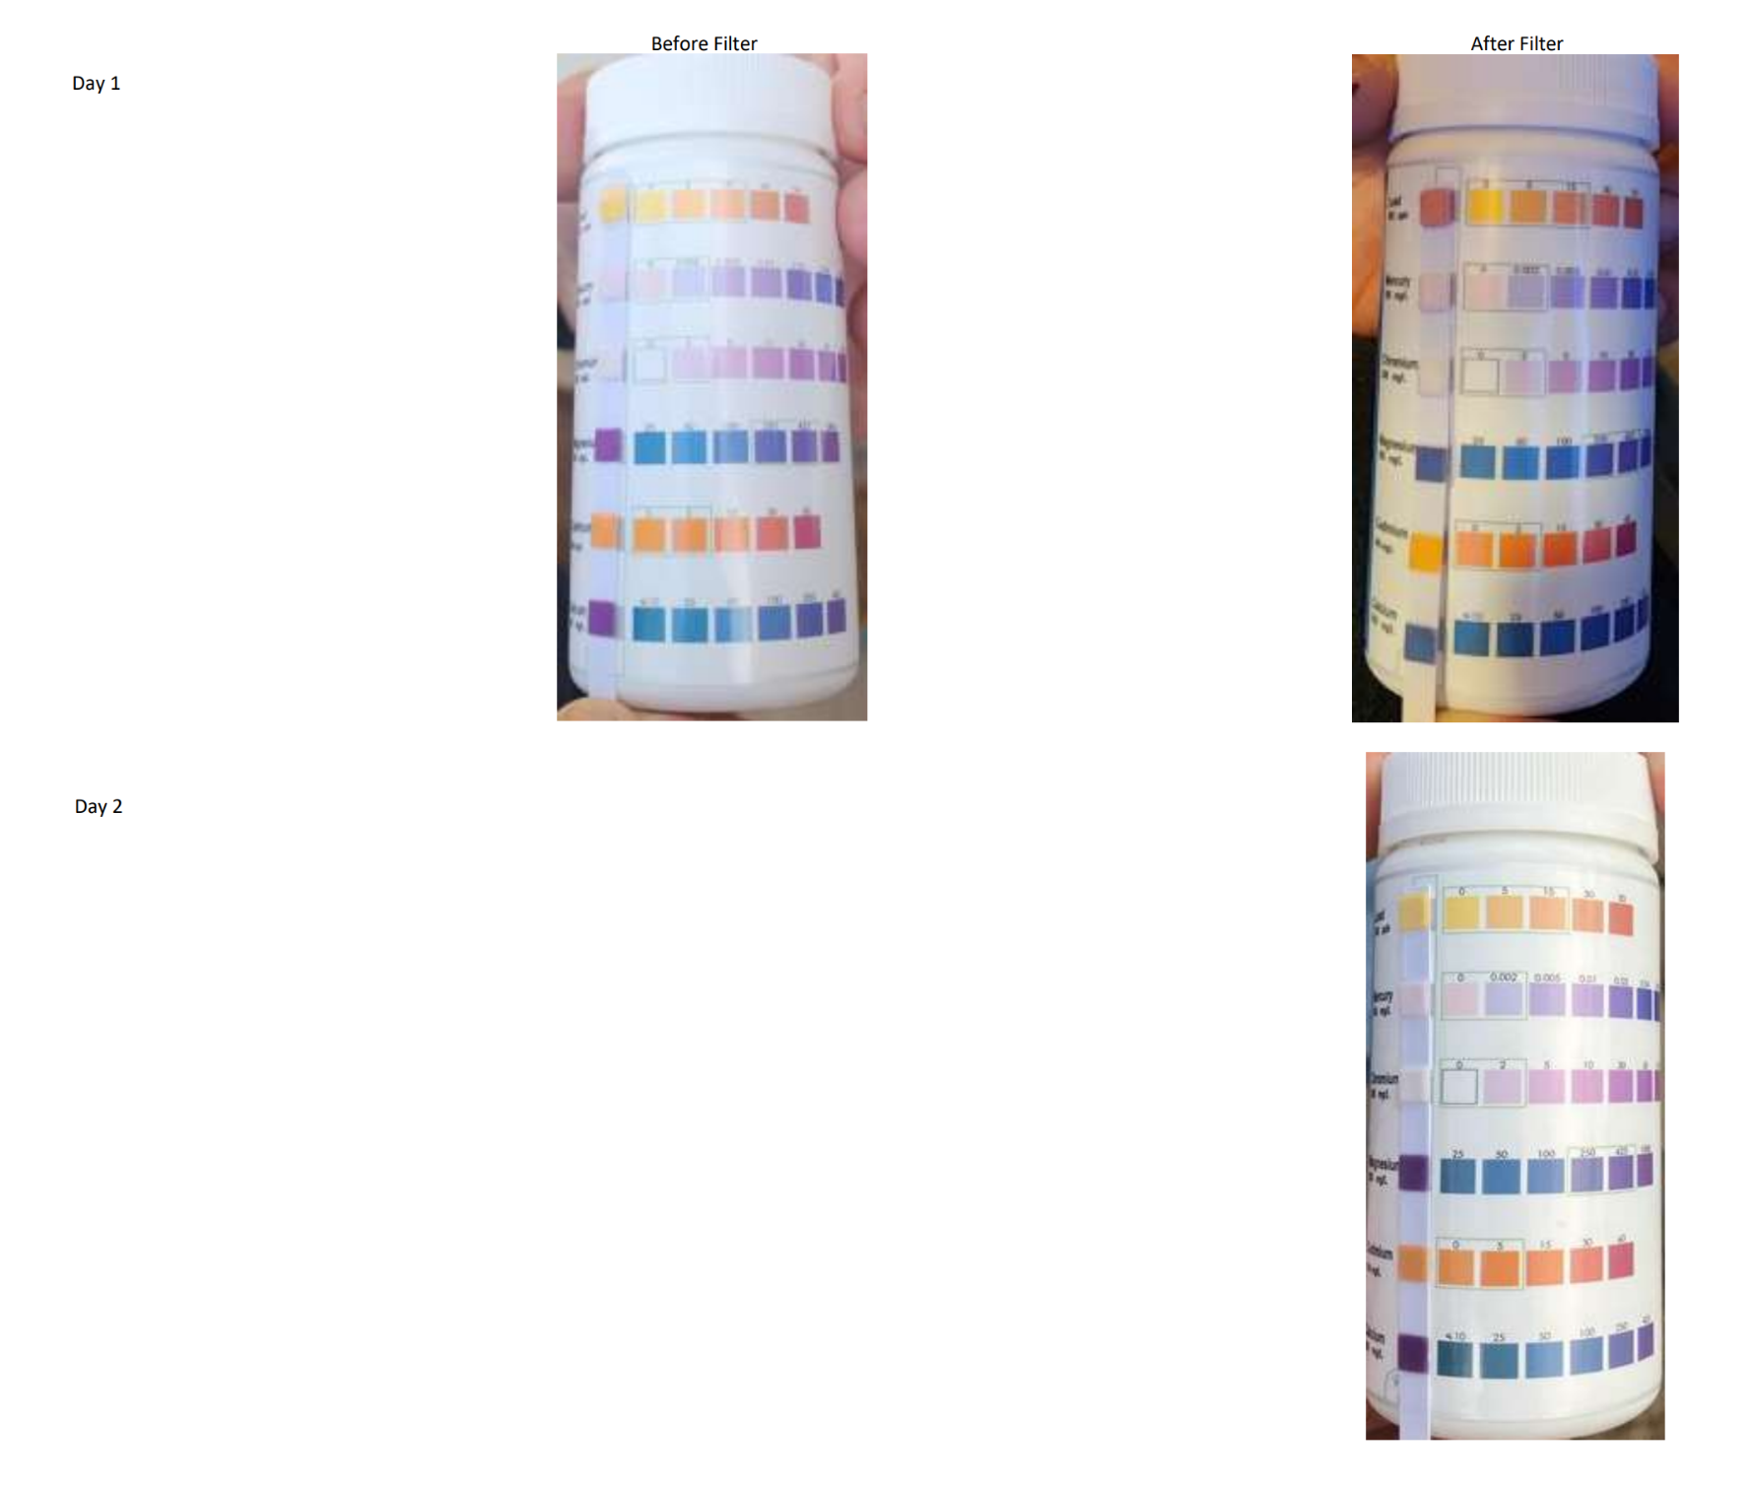

**Figure 2.** Heavy metal test strip results before and after filtration on Day 1 and Day 2. The strips indicate visual changes in lead (Pb) and other metal concentrations. A noticeable increase in lead presence was observed on Day 1 after filtration, likely due to leaching from the coconut-based activated charcoal. No detectable heavy metals were observed after system stabilization on Day 2.

**Appendix D – Arduino & Python Code**

**Appendix E – Photos**

**Appendix F – MSDS Sheets**

**Appendix G – Third-Party Audits (To Be Collected)**